PROBLEM 2:

This Java program takes a decimal number as input along with the target base of any number to input by the user and converts the decimal number to the specified base. It uses a switch statement to determine the target base and then calls the convertToAnyBase method to perform the conversion. The result is printed to the console.

Here's a breakdown of the key components of the code:

i) **main method:**

It prompts the user to enter a decimal number and the target base using a Scanner object.

A switch statement is used to set the target Base variable based on the user's choice.

The convertToAnyBase method is called to perform the conversion, and the result is printed to the console.

ii) **convertToAnyBase method:**

It takes two parameters, n (the decimal number to be converted) and b (the target base).

If the input decimal number n is 0, it returns "0" since the conversion is straightforward in that case.

It uses a StringBuilder named result to build the converted representation.

Inside a while loop, the method repeatedly calculates the remainder when dividing n by b and appends the corresponding digit to the result.

ii) **getDigit(int remainder) method:**

For bases greater than 10, it uses letters ('A' to 'F') to represent digits 10 to 15.

The loop continues until n becomes 0.

The final result is obtained by reversing the order of characters in the StringBuilder and converting it to a string.

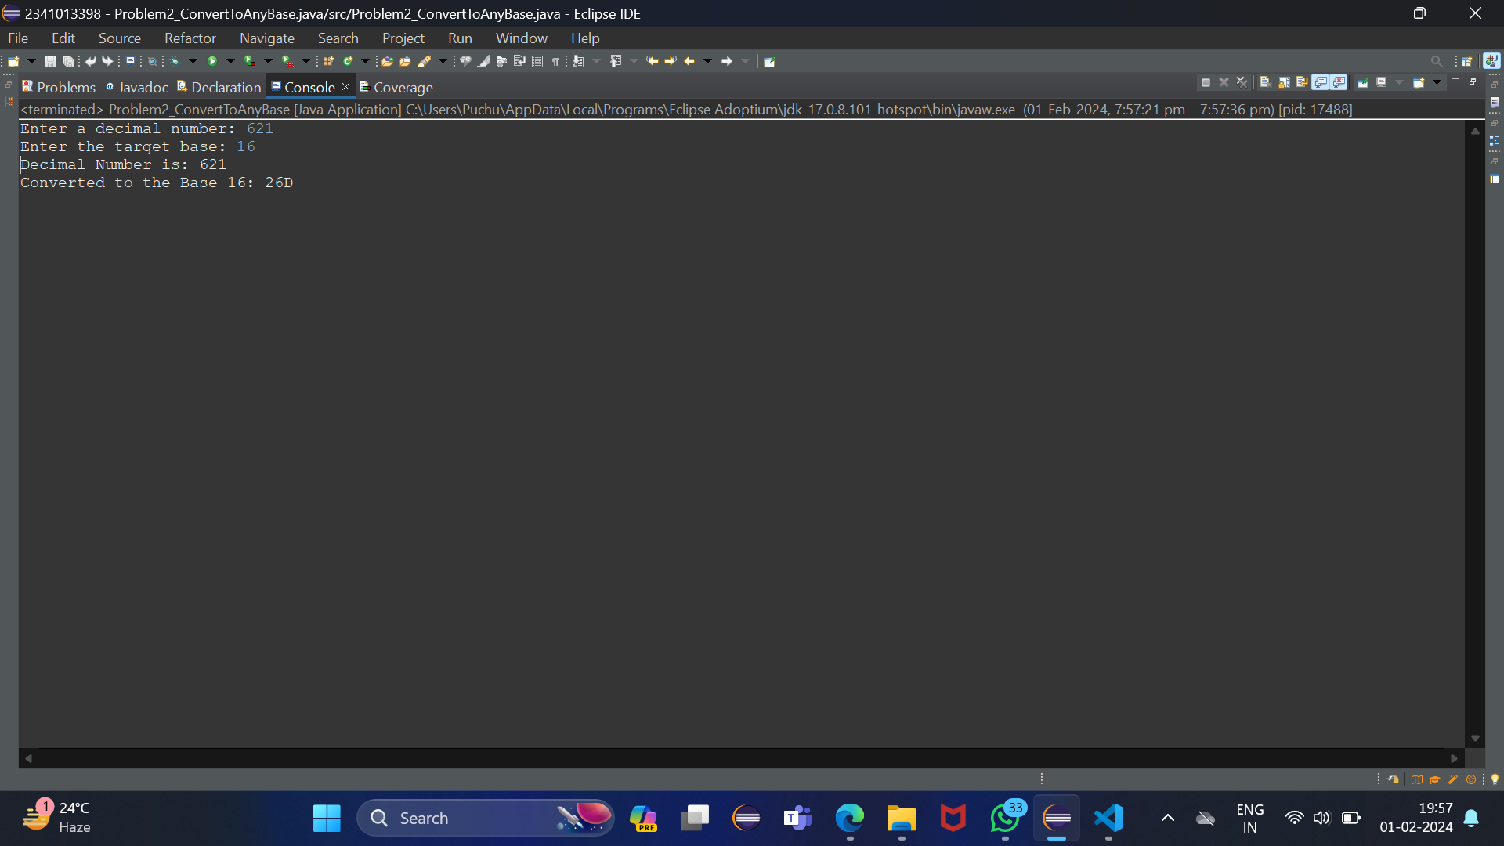OUTPUT: